|  |  |  |
| --- | --- | --- |
| **SPACE CODE** |  |  |
| **CONTENTS**  **- Team Information**  **- Project description** |  |

| Our team | Team Information |
| --- | --- |
| Lubo Krasimirov Dimov | Q&A |
| Miroslav Stoyanov Chobanov | Back-end |
| Maxim Plamenov Mateev | Back-end |
| Gabriel Svetlozarov Yanchev | Font-end |
| Yavor Dimitrov Penkov | Scrum |
|  |

* Project description

A console application, about electronic school with 6 tests, where you can exercise your skills 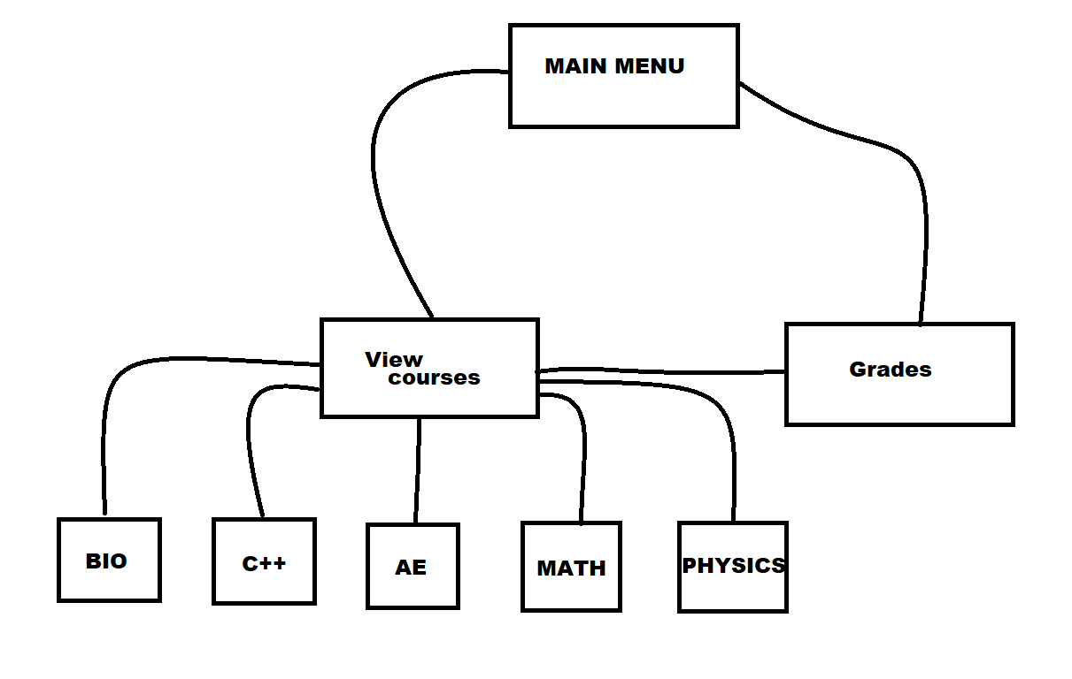

The project was built by “ C++ ”